# Michael Chillemi

# 07/12/2023

# CS 590 - Algorithms

# M8.B3: Module 8 The Greedy Method Application Exercises

Problem 10.5.21

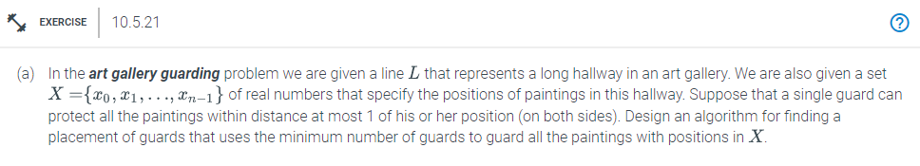

Answer:

Algorithm ArtGalleryGuarding(X,d):

Input: X,d

Output: guardList

position = 1

guardList[]

//Sorting X in increasing order

sort(X)

for i < x.size

if X[position] > lastGuard + d

lastGuard = X[position] + d

guardList.add(lastGuard)

return guardList

The previously described algorithm is intended to position the bare minimum of guards in the hallway of the art museum. To start, the list X is sorted in ascending order. After that is finished, we enter a for loop that continues until i exceeds the length of the list X. The position of the painter is then compared to the position of the last guard plus the distance variable. If so, we put a guard in that position and add their name to the list of guards. The algorithm will provide a list of guards with their positions after the for loop has finished.